The purpose of this design report is to outline the overall design of the system we are producing. This will include the user interface design, the database design and the design of what users of the system will be able to do.

Aims of the system:

This is the design of a learning application that can help students with their studies and teachers to teach. This is done through allowing users to create resources in the form of dictionaries, flashcards and quizzes.

Resources will be shared through making them public and accessible in the public domain or through Classruum’s where every member of the Classruum will be able to access the resources shared by its educator.

The decision has been made to make the application in javafx as the group is familiar with java as a programming language. MySQL will be used for the database structure.

When it will be online

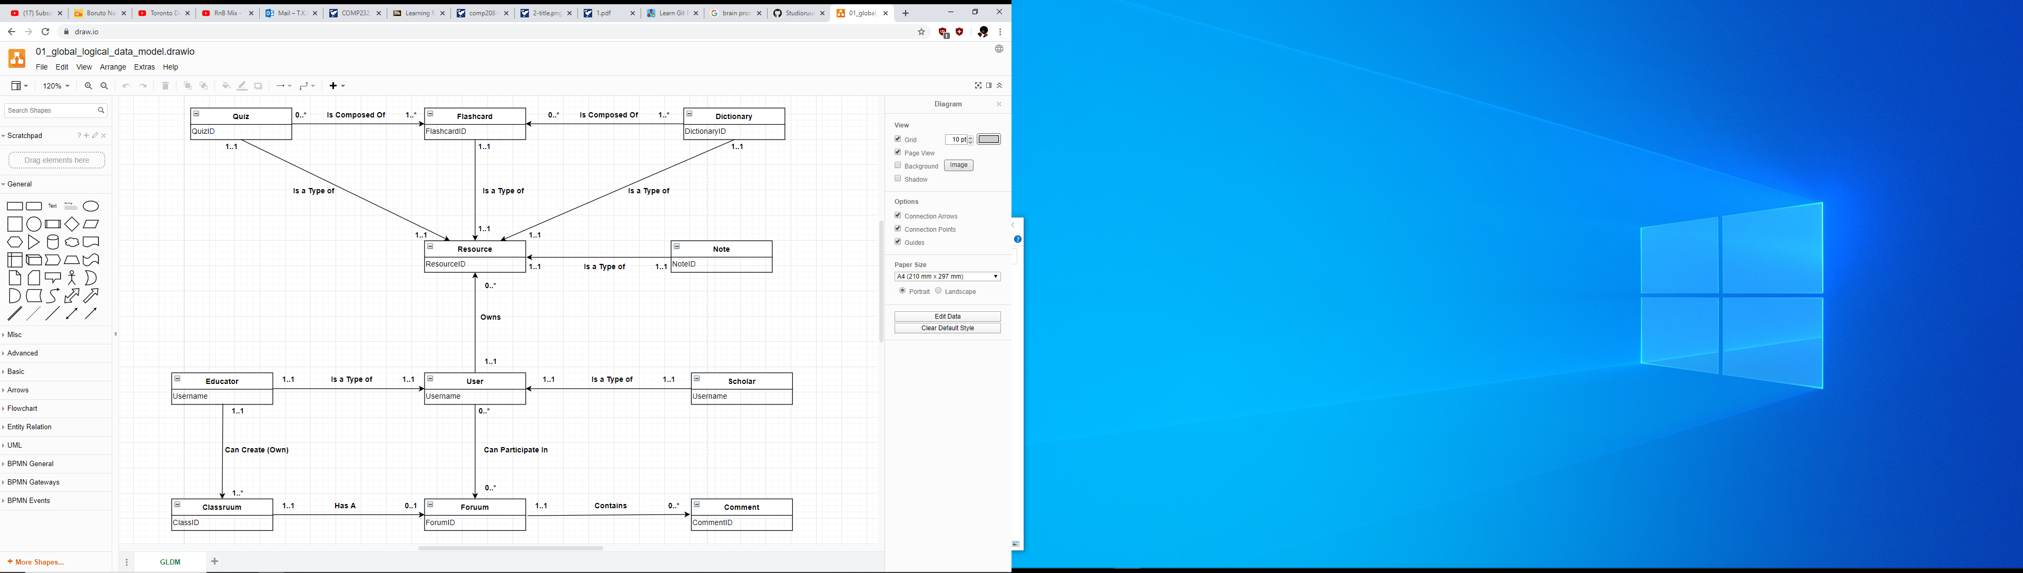

A user is the account which will interact with the resources. Types of user are Educator and scholar which are identified by their username. The educator can create a classrum which can be joined by many scholars. A classrum is identified by its classid.

|  |  |  |  |
| --- | --- | --- | --- |
| **Entity Name** | **Description** | **Aliases** | **Occurrence** |
| Quiz | A sorted collection of flashcards which can be from different sets of Dictionaries | Test | Zero or more Quizzes are composed by one or more Flashcards. Each Quiz is a type of resource |
| Flashcard | A resource containing two sides of text |  | Each Flashcard is a type of Resource |
| Dictionary | A collection of flashcards related to a topic | Deck | One or more Dictionaries is composed by zero or more Flashcards. Each Dictionary is a type of Resource |
| Resource | Some form of learning material | Item | A Resource can be owned by one and only one user |
| Note | A resource containing one side of text, which can be formatted according to the user |  | Each Note is a type of Resource |
| User | Someone that has access to the system | Account | One user can own multiple Resources. Zero or more Users can participate in Foruums |
| Scholar | General user who does not have class creating privileges | Student | Each and every Scholar is a type of User |
| Educator | User with the ability to create and manage classes | Teacher | Each and every Educator is a type of User. One Educator can own one or multiple Classruums |
| Classruum | A group that allows Educators to share resources with Scholars | Class | One or multiple Classruums can be owned by one Educator |
| Foruum | A public domain conversation hub which can be directly related to a specific Classruum | Forum | A single Forum can or cannot be directly related to a specific Classruum |
| Comment | An interaction posted by the User on a specific Foruum | Interaction | Zero or more Comments are contained in a particular Forum |

|  |  |  |  |  |
| --- | --- | --- | --- | --- |
| **Entity** | **Multiplicity** | **Relationship** | **Multiplicity** | **Entity** |
| Quiz  Quiz | 0..*  1..1 | IsComposedOf  IsaTypeOf | 1..*  1..1 | Flashcard  Resource |
| Flashcard | 1..1 | IsaTypeOf | 1..1 | Resource |
| Dictionary  Dictionary | 1..*  1..1 | IsComposedOf  IsaTypeOf | 0..*  1..1 | Flashcard  Resource |
| Resource | None | None | None | None |
| Note | 1..1 | IsaTypeOf | 1..1 | Resource |
| User  User  User | 1..1  0..*  1..1 | Owns  CanParticipateIn  CanPost | 0..*  0..*  0..* | Resource  Foruum  Comment |
| Scholar  Scholar | 1..1  0..* | IsaTypeOf  CanBeAMemberOf | 1..1  0..* | User  Classruum |
| Educator  Educator | 1..1  1..1 | IsaTypeOf  CanCreate | 1..1  1..* | User  Classruum |
| Classruum | 1..1 | HasA | 0..1 | Foruum |
| Foruum | 1..1 | Contains | 0..* | Comment |
| Comment | None | None | None | None |

|  |  |  |  |  |
| --- | --- | --- | --- | --- |
| **Entity** | **Attributes** | **Description** | **Data type and Length** | **Nulls** |
| Quiz | QuizID  ResourceID  QuizName  QuizTopic | Uniquely identifies a quiz  Uniquely identifies a resource  Name of the Quiz  Topic of the Quiz | 6 variable integers  6 variable integers  30 variable characters  30 variable characters | No  No  No  Yes |
| Flashcard | FlashcardID  ResourceID  DictionaryID  QuizID  FrontContent  BackContent | Uniquely identifies flashcard  Uniquely identifies resource  Uniquely identifies containing Deck  Uniquely identifies containing Quiz  Content (text, etc) on the front of the card  Content (text, etc) on the front of the card | 6 variable integers  6 variable integers  6 variable integers  6 variable integers  255 variable characters  255 variable characters | No  No  No  No  No  No |
| Dictionary | DictionaryID  ResourceID  DictionaryName | Uniquely identifies Dictionary  Uniquely identifies Resource  Name of the Dictionary | 6 variable integers  6 variable integers  30 variable characters | No  No  No |
| Resource | ResourceID  UserID | Uniquely identifies Resource  Identifies user owning Resource | 6 variable integers  6 variable integers | No  No |
| Note | NoteID  ResourceID  NoteTitle  NoteContent | Uniquely identifies Note  Uniquely identifies Resource  Title of the Note  Content (text, etc) of the note | 6 variable integers  6 variable integers  30 variable characters  255 variable characters | No  No  No  No |
| User | UserID  Username  Email  Password | Uniquely identifies User  Username of User  Email of User  Password for the User account | 6 variable integers  15 variable characters  255 variable characters  127 variable characters | No  No  No  No |
| Scholar | ScholarID  UserID | Uniquely identifies Scholar  Uniquely identifies User | 6 variable integers  6 variable integers | No  No |
| Educator | EducatorID  UserID | Uniquely identifies Educator  Uniquely identifies User | 6 variable integers  6 variable integers | No |
| Classruum | ClassID  EducatorID  ClassName | Uniquely identifies Classruum  Identifies owning Educator  Name of the Classruum | 6 variable integers  6 variable integers  30 variable characters | No  No  No |
| Foruum | ForumID  ClassID  ForumTitle | Uniquely identifies Foruum  Identifies Class tied to Foruum  Title of the Foruum | 6 variable integers  6 variable integers  30 variable characters | No  Yes  No |
| Comment | CommentID  ForumID  CommentContent  UserID | Uniquely identifies Comment  Identifies containing Foruum  Content (text, etc) of the Comment  Identifies User which posted Comment | 6 variable integers  6 variable integers  255 characters  6 variable integers | No  No  No  No |

|  |  |  |  |  |
| --- | --- | --- | --- | --- |
| **Entity** | **Attributes** | **Description** | **Key** | **Nulls** |
| Quiz | QuizID  ResourceID  QuizName  QuizTopic | Uniquely identifies a quiz  Uniquely identifies a resource  Name of the Quiz  Topic of the Quiz | Primary key | No  No  No  Yes |
| Flashcard | FlashcardID  ResourceID  DictionaryID  QuizID  FrontContent  BackContent | Uniquely identifies flashcard  Uniquely identifies resource  Uniquely identifies containing Deck  Uniquely identifies containing Quiz  Content (text, etc) on the front of the card  Content (text, etc) on the front of the card | Primary key | No  No  No  No  No  No |
| Dictionary | DictionaryID  ResourceID  DictionaryName | Uniquely identifies Dictionary  Uniquely identifies Resource  Name of the Dictionary | Primary key | No  No  No |
| Resource | ResourceID  UserID | Uniquely identifies Resource  Identifies user owning Resource | Primary key | No  No |
| Note | NoteID  ResourceID  NoteTitle  NoteContent | Uniquely identifies Note  Uniquely identifies Resource  Title of the Note  Content (text, etc) of the note | Primary key | No  No  No  No |
| User | UserID  Username  Email  Password | Uniquely identifies User  Username of User  Email of User  Password for the User account | Primary key  Alternate key | No  No  No  No |
| Scholar | ScholarID  UserID | Uniquely identifies Scholar  Uniquely identifies User | Primary key | No |
| Educator | EducatorID  UserID | Uniquely identifies Educator  Uniquely identifies User | Primary key | No |
| Classruum | ClassID  EducatorID  ClassName | Uniquely identifies Classruum  Identifies owning Educator  Name of the Classruum | Primary key | No  No  No |
| Foruum | ForumID  ClassID  ForumTitle | Uniquely identifies Foruum  Identifies Class tied to Foruum  Title of the Foruum | Primary key | No  Yes  No |
| Comment | CommentID  ForumID  CommentContent  UserID | Uniquely identifies Comment  Identifies containing Foruum  Content (text, etc) of the Comment  Identifies User which posted Comment | Primary key | No  No  No  No |

|  |  |
| --- | --- |
| **Class**(ClassID, EducatorID, Class_Name)  **Primary Key** ClassID  **Foreign Key** EducatorID *references* **Person**(Username) |  |

**Logical tables**

**Physical tables**

**Person Table**

Domain Account_Type Variable length string maximum length 8 // could just be fixed sized (E or S)

Domain Email_Adress Variable length character string maximum length 50

Domain Username Variable length character string maximum length 30

Domain Password Variable length character string maximum length 50

Domain Clasruum Variable length character string maximum length 5 // could store as integer

Time_Created TIMESTAMP

Person( Account_Type Account_Type NOT NULL

Email Email_Address NOT NULL

Username Username NOT NULL

Hashed_Password Password NOT NULL

ClassID Classruum NULL

Created Time_Created NOT NULL

Primary Key Username

Alternate Key Email

Foreign Key ClassID references Class(ClassID)

**Resources Table**

Domain Resource_Type Variable length string maximum length 10 // could just be fixed sized (Q, F OR N)

Domain Resource_Code Variable length character string maximum length 6 //like Q1234 for a quiz

Domain Resource_Name Variable length character string maximum length 30

Domain Owner Variable length character string maximum length 30

Domain Privacy Variable length character string max size 7 if public/private/shared //Alternatively call it public and use binary data type

Resources(Type Resource_Type NOT NULL

Code Resource_Code NOT NULL

Name Resource_Name NOT NULL

Creator Owner NOT NULL

Privacy Privacy NOT NULL

Primary Key Code

Foreign Key Creator references Person(Username)

**Class Table**

Domain ClassID Variable length string maximum length 5 //C208

Domain ClassName Variable length character string maximum length 25 //Mr Carrol’s Class

Domain Owner Variable length character string maximum length 5

Class(ClassID ClassID NOT NULL

Class_Name Name NOT NULL

EducatorID Owner NOT NULL

Primary Key ClassID

Foreign Key EducatorID references Person(Username)

**Foruum Table**

Domain ForumID Integer

Domain Forum_Title Variable length character string maximum length 25

Domain Closed Binary

Domain Owner Variable length character string maximum length 30

Domain Time_Created TimeStamp

Forum(ForumID Resource_Type NOT NULL

Closed Closed NOT NULL

Creator Owner NOT NULL

Created Time_Created NOT NULL

Forum_Title Forum_Title NOT NULL

Primary Key ForumID

Foreign Key Creator references Person(Username)

**Comment Table**

Domain CommentID Integer

Domain ForumID Integer

Domain Comment_Content Variable length character string maximum length 300

Domain Owner Variable length character string maximum length 30

Domain Time_Created TimeStamp

|  |  |  |
| --- | --- | --- |
| Comment( | CommentID | CommentID NOT NULL |
| ForumID | ForumID NOT NULL |
| Content | Comment_Content NOT NULL |
| Creator | Owner NOT NULL |
| Created | Time_Created NOT NULL |
| Primary Key CommentID | |
| Foreign Key Creator references Person(Username) | |
| Foreign Key ForumID references Forum(ForumID) | |

These tables will be created in MySQL

Transaction Table

I = input   
R= read

U=update

|  |  |  |  |  |  |  |  |  |  |  |  |  |  |  |  |  |  |  |  |  |  |  |  |  |  |  |  |  |  |  |  |  |  |  |
| --- | --- | --- | --- | --- | --- | --- | --- | --- | --- | --- | --- | --- | --- | --- | --- | --- | --- | --- | --- | --- | --- | --- | --- | --- | --- | --- | --- | --- | --- | --- | --- | --- | --- | --- |
| Transaction /  Table | Create new member | | | | Make Classruum | | | | Make Foruum | | | | Make quiz | | | | | Comment | | | | Make note | | | | Join Classruum | | | | Search for quiz/foruum | | | | |
|  | I | R | U | D | I | R | U | D | I | R | U | D | | I | R | U | D | I | R | U | D | I | R | U | D | I | R | U | D | I | R | U | D |
| Educator | x |  |  |  | x |  |  |  | x |  |  |  | | x |  |  |  |  |  | x | x |  |  |  |  |  |  |  |  |  |  |  |  |
| Scholar | x |  |  |  |  |  |  |  | x |  |  |  | | x |  |  |  |  |  | x | x |  |  |  |  | x |  |  |  |  |  |  |  |
| Classruum |  |  |  |  |  |  | x |  |  |  |  |  | |  |  |  |  |  |  | x |  |  |  |  |  |  | x | x |  |  |  |  |  |
| Foruum |  |  |  |  |  |  |  |  |  |  | x |  | |  |  |  |  |  |  | x |  |  |  |  |  |  |  |  |  |  | x |  |  |
| Quiz |  |  |  |  |  |  |  |  |  |  |  |  | |  |  | x |  |  |  |  |  |  |  |  |  |  |  |  |  |  | x |  |  |
| Notes |  |  |  |  |  |  |  |  |  |  |  |  | |  |  |  |  |  |  |  |  |  |  | x | x |  |  |  |  |  |  |  |  |

D=delete

1.Enter details of new member

2. Make classruum

3. Create foruum

4. Create quiz

5. Comment

6. Create note

7. Join classruum

8. Search for quiz/foruum

**Interface Design Explanation**

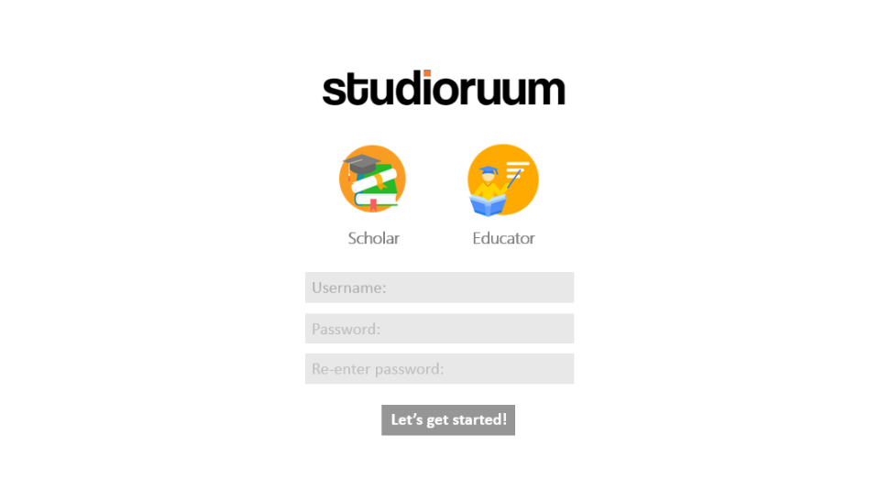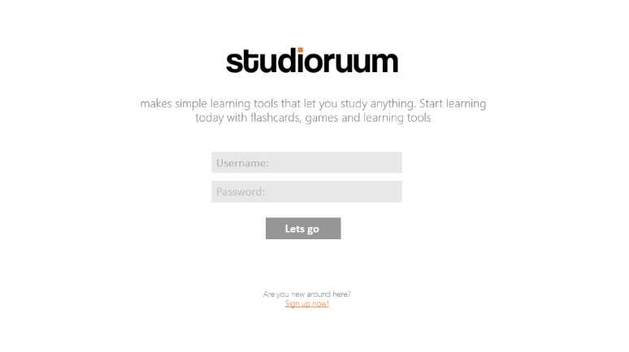In the initial design for our interface, we had to consider the form and functionality of our program. We have chosen to implement a more professional approach (whilst maintaining our accessibility) compared to the likes of competitor applications (for example Quizlet). This is denoted through our simplistic and minimalistic colour pallet (pastel) and ease of access. to We ensured to fulfil the objectives specified in the requirements whilst maintaining the theme and visual representation of our product. Our target demographic are students (age 15-25) and teachers.

User can choose their preferred account type: Scholar or Educator

Button that will take them to home page, if their account credentials are correct. Chose to used colloquial verbiage to connote accessibility, and make the program appear more user friendly.

If user is new, they can create a new account, which will lead them to the next page: create account.

Greet the user with the logo and a short sentence that explains what our program does.

**Page: 1**

**Page: 2**

Button that will take them to home page, and add the users account to the database saving there username/email, password and account type.

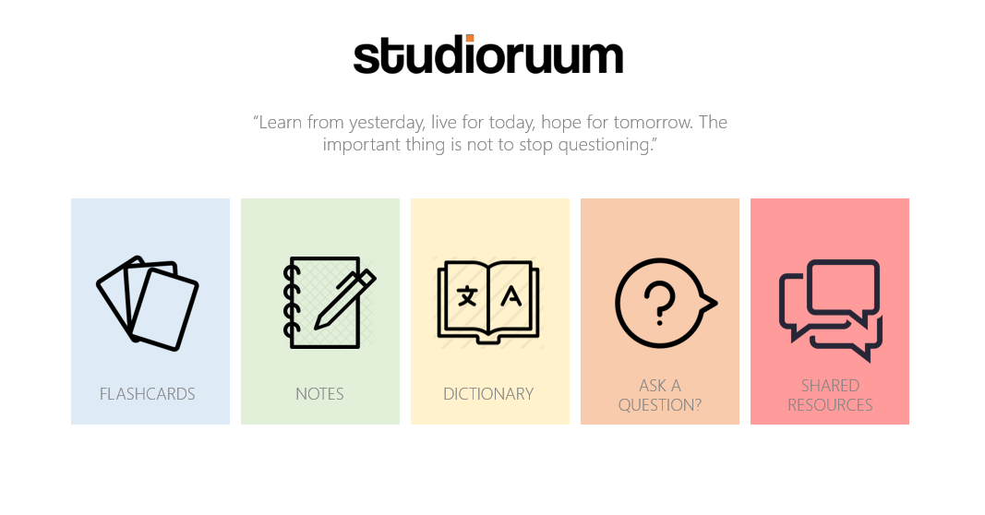

**Page: 3**

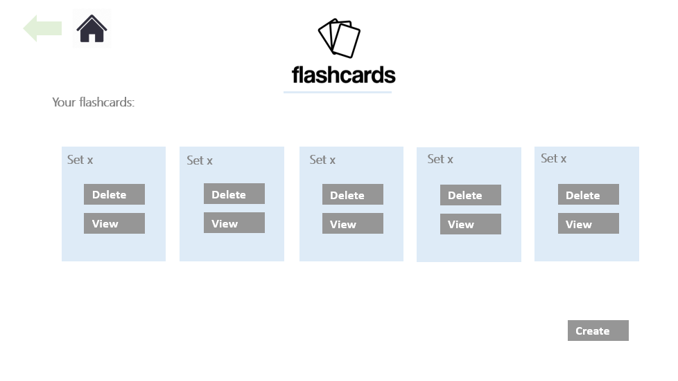

Back button used to navigate to previous page. (Can be used if the user makes a mistake)

**Page: 4**

View will take to view flash card page. (page **5**.)

Home button takes to home page

This shows the users flash card sets, and allows the user to view or delete them

This shows the users flash card sets, and allows the user to view or delete them

This indicates the page the user is on.

This will take them to the view dictionaries where they can save and delete sets of dictionaries

This will take them to the view notes where they can save and delete sets of notes

This will take them to the view flashcards where they can save and delete sets of flashcards

Short quote that used to inspire the user.

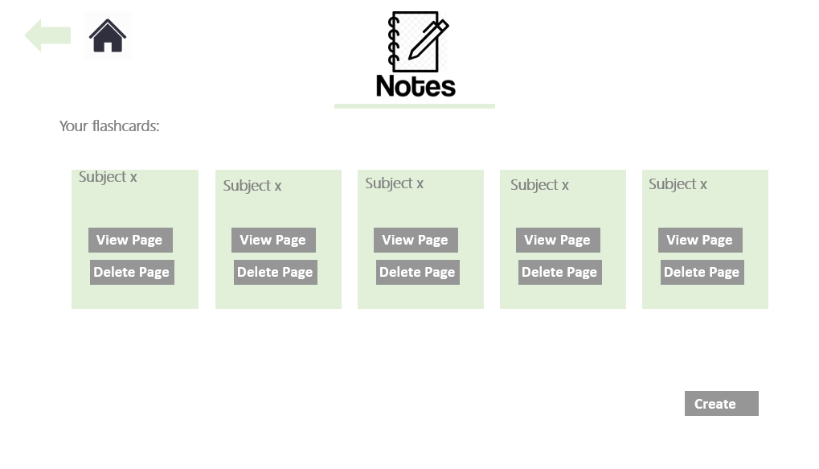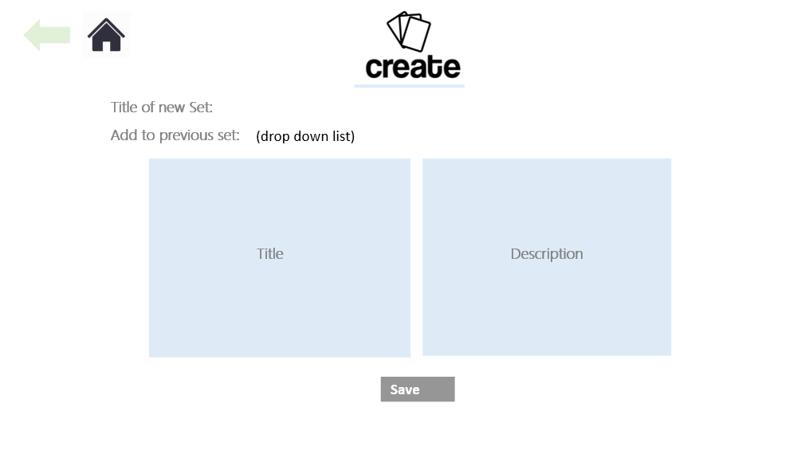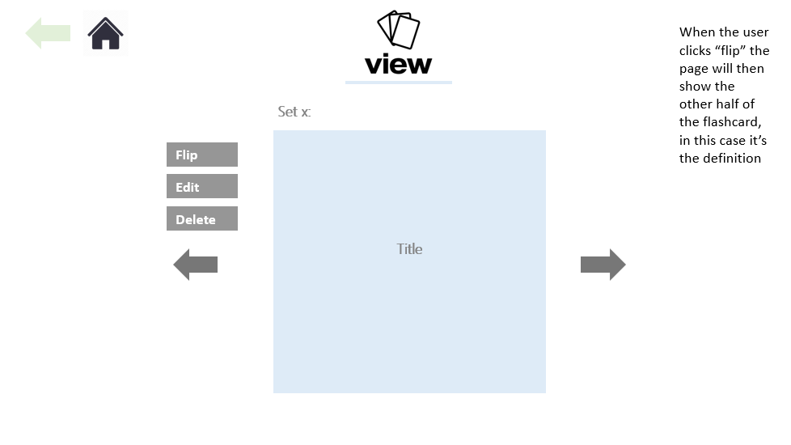

Will take you to view notes page **(page 8)**

Will take you to create notes page

**Page: 5**

**Page: 7**

**Page: 6**

Save button will save combination into database.

Edit button lets you change text in the card

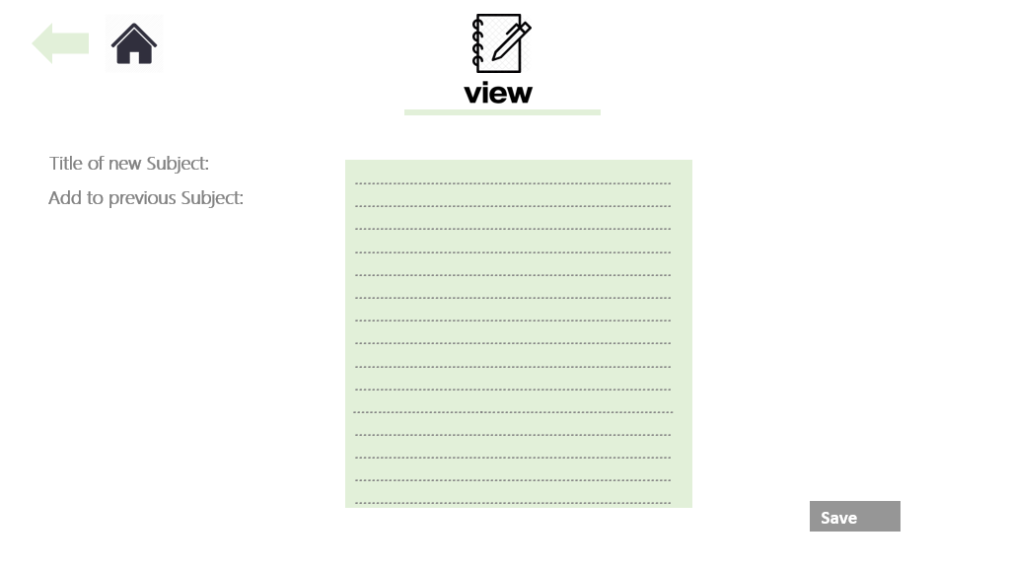

**Page: 9**

Button saves notes to the database and into the subject (new or previous)

Choose whether to name a new set or save note in another subject

**Page: 8**

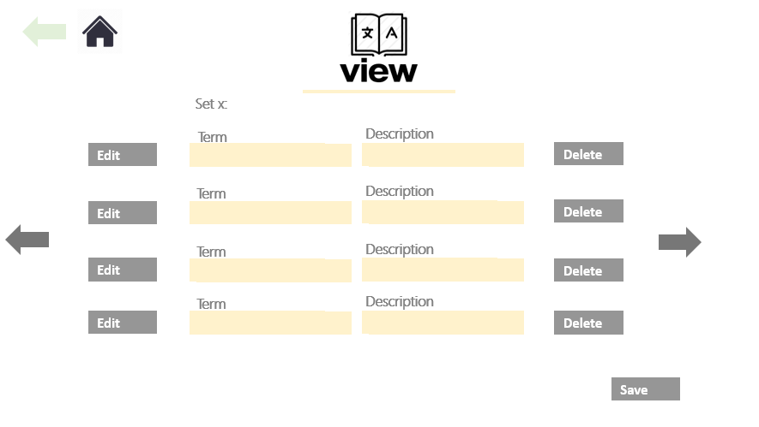

This will delete the attributes in the database.

This will delete the attributes in the database.

# Signatures

In the Order - Lloyd Jones, Daniel Ponturo, Tyler Bunsie, Bobby-Chase Davies, Lachlan Smith, Jordan Clewlow.

